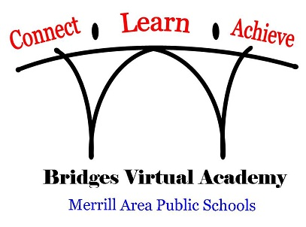
1201 N Sales Street
Merrill, WI 54452
(715) 539-8360 (844) 274-3437

Bridges Virtual Academy

STUDENT ACADEMIC TRANSCRIPT REQUEST

PLEASE COMPLETE A SEPARATE FORM FOR EACH REQUEST YOU ARE SUBMITTING.

I am requesting academic transcripts regarding my student/self:

Student/Self Last Name:

Student/Self First Name:

Student/Self Maiden Last Name (if applicable):

Graduation Year:

Contact Email Address:

BVA is authorized to forward the above named student’s official academic transcript from BVA to the organization listed below. The submitter of this request is responsible for the accuracy of the email or mailing address provided. (Parental permission (signature) is not required when transcripts are requested by a current or former student who is 18+ years of age.)

Name of Organization to Send Transcript To:

Mailing Or Email Address of Organization:

Name of Person Submitting This Request Date

This form should be returned to mary.ball@bridgesvirtualacademy.com or may be mailed to:
Mary Ball, Bridges Virtual Academy, 1201 North Sales Street, Merrill, WI 54452

************************************************************ BVA Office Use Only

Completed by: ________________________________________ Date Sent to Organization: ____________

